

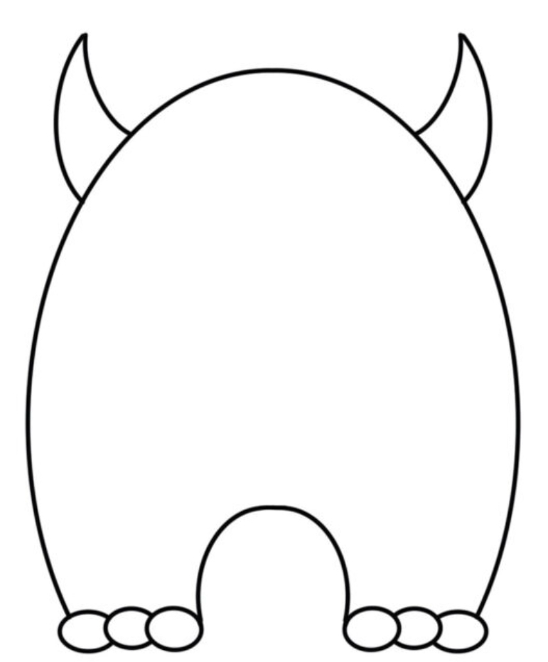
Design A Monster 2025

Name………………………………………………….
I am in:
□ | Nursery | □ | Reception
□ | Year 1 | □ | Year 2

Design A Monster Competition 2025

Put your design skills to the test to create your own monster!
Do you want to create a collage using cuttings from a magazine, or you enjoy using watercolour paints? It could be that creating a pattern using colouring pencils is more your style; the possibilities are endless, and we cannot wait to see how creative you all are!
Entry costs £1, and the competition closes on Friday 7th November which gives you the whole of the October holidays to put your creativity to the test and make a prizewinning design!
Entries must be handed into the school office by the end of the day on Friday 7th, along with your £1 entry fee.
A digital copy will be made available should you want to reprint this or print it onto thicker paper, better suited for your artwork.
An overall winner will take home A FAMILY TICKET TO LIGHT POST FARM, two runners up will be chosen from each year group and each will win a prize.
Winners will be announced the following week.
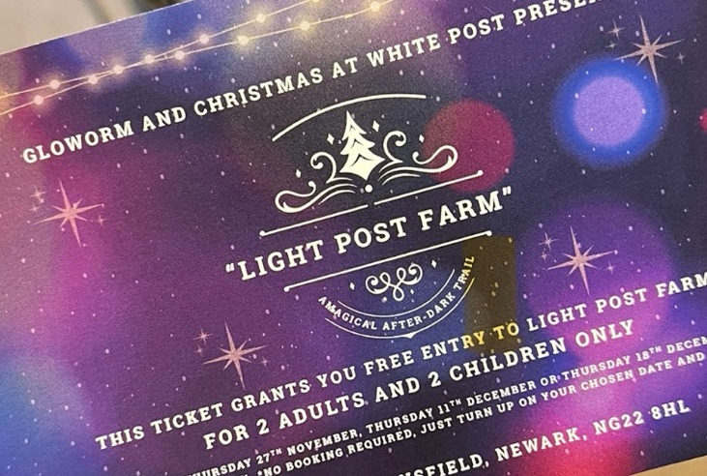

Good Luck, and have fun!
The Friends

