Mtp –Spring 2- FS2
Wk | Topic | COEL –  Intent is continuous all term | COMMUNICATION & LANGUAGE  (Listening, attention & understanding, speaking) | PSED  (Self-regulation, Managing self  & Building relationships) | PHYSICAL  (Gross motor & Fine motor) | LITERACY (Comprehension, Word reading phonics & Writing) | MATHEMATICS (Number, Numerical patterns & SSM) | UNDERSTANDING THE WORLD  (Past & present, People, culture & communities & The natural world) | EXPRESSIVE ARTS & DESIGN  (Creating with materials, Being imaginative and expressive) | Key vocab
WK-1  WB 19.02.2O24 | Pet week | I can plan a game or activity and consider what I want to achieve during and after completion.  I can show perseverance with my work.  I can seek help from friends or teachers.  I know the daily routines and can prepare myself for them.  I can make links between my own interests and my learning. | I can hold conversations and talk in a small group  I can use new vocabulary that I have learned.  I can listen carefully and respond with comments and questions. | I can set myself an achievable goal and know how I am going to achieve this.  I can talk about the ways in which I have changed since starting school.  I can recognise the ways in which I have become more confident. | I can attempt to turn my socks/tights/clothes the right way round ready for me to wear again.  I can cut out a variety of shapes on different textures confidently.  I consider the shape, size and details in my drawings, I can make them smaller/larger where appropriate.  I can use a variety of pens, pencils, crayons, wax crayons and apply the correct pressure based on which tool I am using at the time. | I can apply the Level 1+ and Level 2 graphemes to my reading and writing mostly consistently.  I can blend sounds to read words and sight read some familiar words, particularly VC words.  I can sometimes use a capital letter, finger space and full stop in my sentence writing, but I am not yet consistent with this.  I can talk about the text I read in both fiction and non-fiction texts and make links to my own thoughts, opinions and experiences. | I can say what is one more and one less than a given number.  I can use the Ten Frame for addition and subtraction to 10.  I can use the Part Part Whole Model for simple addition. | I can explore the natural world around me and make observations.  I can make observations of animals and draw them.  I can say how some animals are similar and different. | I have a good understanding of colour mixing and can carefully select colours for specific purposes.  I can use tessellation confidently for collaging.  I can use a wide variety of art tools with good control and understanding of their purpose. | Perseverance  Resilience  Confidence  Silhouette  Pets/vets
 |  |  | Encourage children to learn and use new vocabulary to describe pets and their babies.  Learn animal names such as kitten, puppy, chick, along with adjectives eg soft, fluffy, scaly, smooth.  Sing Old MacDonald had a house – replace farm animals with pets. Children perform their song to others and follow the rhythm.  Listening to stories, songs and rhymes and respond with comments and questions. | Setting ourselves goals and talking about how we are going to achieve these – taking small steps, practising a skill, building confidence, etc.  Understanding the words perseverance and resilience and thinking about if you display this while working on a task.  Recognising how we have grown in confidence since starting school and how we can help others to become more confident in particular situations – Stories, talking about how we can help and encourage friends. | Moving animal– cutting more complex shapes, using a braddle for linking legs to body with split pins – adding detail and colour using variety of resources.  Handwriting in books – graphemes from phonics this week.  PE – Twinkl plan 1 – Jumping and Rolling | Model key features of a sentence again as a recap – particular focus on capital letters for names.  Introduce the word ‘because’ for linking ideas.- ‘I want a pet because’  Library books – pet stories and nonfiction text about pets.  Group phonics activity.  Floppys phonics Level 2 - /SH/ /TH/ | One more and one less than a given number – number fan warm ups.  Revisit addition to 10 using the Ten Frame and Part Part Whole Model – Maths Dollop, Playdough mats, etc.  Introduce subtraction to 10 using the Part Part Whole Model.  Simple addition and subtraction - Word problems to solve. | Understand similarities and differences between animals. What sort of animals do we have as pets? Look at different animals, why don’t we have a giraffe as a pet?  Draw on their experience of animals. Pets/In the wild? How do they survive? Make observations of different kinds of pets, how are they similar/different?  Do all animal babies look like their parents? Read Monkey Puzzle – Julia Donaldson | Skill focus:  -Silhouette – to understand new language. Drawing around shadows with chalks. Silhouette of a horse in a field to link with theme.  Collaging an animal – recap tessellations when collaging.  Colour mixing – revisit and make a chart for colour mixing  Charanga- Term 4 – music lesson 1
WK-2  WB 26.02.2024 | Creature week | Same as week 1 | I can use new vocabulary in my talk with my friends and peers.  I can listen carefully and make comments about what I have heard.  I can offer explanations for why things might happen in stories. | I can concentrate when somebody is talking to me.  I can concentrate until a game is finished.  I can be a good listener. | I consider the shape, size and details in my drawings, I can make them smaller/larger where appropriate.  I can use a variety of pens, pencils, crayons, wax crayons and apply the correct pressure based on which tool I am using at the time.  I am more confident now when using a knife to cut up my own food.  I can perform basic balances and stretches in PE with increased control.  I can use the PE equipment safely with good control with awareness of the people around me. | I can write the Level 1+ helpful confidently and make good attempts at writing the Level 2 helpful words.  I can apply the Level 1+ and Level 2 graphemes to my reading and writing mostly consistently.  I can blend sounds to read words and sight read some familiar words, particularly VC words.  I can sometimes use a capital letter, finger space and full stop in my sentence writing, but I am not yet consistent with this.  I can talk about the text I read in both fiction and non-fiction texts and make links to my own thoughts, opinions and experiences. | I can recognise and name 2D shapes.  I can talk about the properties of 2D shapes using the relevant vocabulary.  I can recognise and name 3D shapes.  I can talk about the properties of 3D shapes using the relevant vocabulary.  I can recognise 2D and 3D shapes in the environment. | I can explore the world around me and make observations. | I can apply my previous learning to new learning and utilise a mixture of familiar resources, tools and skills when creating new pieces.  I have a good understanding of colour mixing and can carefully select colours for specific purposes.  I can use tessellation confidently for collaging.  I can use a wide variety of art tools with good control and understanding of their purpose. | Concentrate  Coordinating  Creatures
 |  |  | Look at pictures of the creatures. Point out the features, purple prickles, small orange wart, size of the creatures. Encourage children to use new vocabulary.  Encourage children to listen to longer stories and link them to their play and talk.  Forest School - Go on a mythical creatures hunt, give the children an instruction with 2 parts eg ‘Tiptoe to the tree. Then look up.’ Encourage children to listen to the instructions carefully. | Recognising the importance of concentrating when somebody is talking to you – circle time, relate to our BRILLIANT Expectation “We listen.”  Talk about how can we help our concentration improve – games (Kim’s Game, etc), brain breaks  Play listening games – revisit the importance of listening to others, your body language when you listen, etc. | Finger painting mermaids tail for fine motor skills and dexterity.  At lunch time focus on children still needing support with cutting food up.  Make a shape monster – cutting variety of shapes and patterns.  PE – Twinkl plan 2 – Jumping and Rolling  Handwriting in books – graphemes from phonics this week | Recap key features of a sentence – children to design a shape monster and write about their monster.  Writing helpful words in the morning.  Floppys phonics Level 2 - /NG/ | Revisit 2D shapes and their properties – Games, Maths Dollop, Shapes in the water, etc.  Go on a 2D and 3D shape hunt to recognise shapes in the environment.  2D shape patterns – Printing, Drawing around shapes,  Revisit 3D shapes and their properties – Games, Matching shapes, etc  Describing both 2D and 3D shapes using the relevant vocabulary. | Are the creatures friendly or mean? Show pictures of armour, discuss the material that was used to make strong armour.  Explore magnetism - Look at different metals – spoons, coins, etc. | Skill focus:  Finger painting – coordinating different colours on each finger.  Group collaging project – combining materials and resources together, working as part of a team to create a collage.  Charanga- Term 4 – music lesson 2
WK-3  WB 04.04.2024 | Dinosaur week | Same as week 1 | I can use full sentences to describe settings using the correct tense (with teacher support).  I can begin to use conjunctions when I talk and express my ideas and feelings.  I can listen and show understanding of what I have heard through comments and questions. | I can talk about the qualities that make a good friend.  I can show patience, share and take turns and know why these are important. | I can use the principles of pinchy parrot fingers for correctly holding different tools.  I can attempt to turn my socks/tights/clothes the right way round ready for me to wear again.  I can cut out a variety of shapes on different textures confidently.  I consider the shape, size and details in my drawings, I can make them smaller/larger where appropriate.  I can use a variety of pens, pencils, crayons, wax crayons and apply the correct pressure based on which tool I am using at the time.  I can perform basic balances and stretches in PE with increased control. | I can talk about the text I read in both fiction and non-fiction texts and make links to my own thoughts, opinions and experiences.  I can apply the Level 1+ and Level 2 graphemes to my reading and writing mostly consistently.  I can blend sounds to read words and sight read some familiar words, particularly VC words. | I can draw a familiar route showing landmarks and features that I pass.  I can use positional language to describe where a landmark is on a route or map.  I can draw a map to reproduce a route from a story.  I can draw a map showing landmarks and features in the correct position.  I can read a map and then position features on it in the correct place on a small world version. | I can understand settings in the past through books and storytelling.  I can understand important processes in the changing state of matter.  I can talk about some similarities and differences between the past and now. | I have a good understanding of colour mixing and can carefully select colours for specific purposes.  I can use a wide variety of art tools with good control and understanding of their purpose.  I can apply my previous learning to new learning and utilise a mixture of familiar resources, tools and skills when creating new pieces. | Dinosaur names  Routes/ maps /directions  Ice/Freeze  Pastels – pressure  Landmarks
 |  |  | Listen to and learn a selection of dinosaur themed songs.  Dinosaur-Themed Songs and Rhymes.  Listen carefully to spot rhyming words. Explore sound patterns in the songs.  Engage children in story times and non-fiction texts about dinosaurs. Learn new vocabulary and ask questions to find out more.  Encourage children to retell some of the dinosaur stories in their own words, using the new vocabulary.  Use dinosaur names and describe the dinosaur settings. | Talking about friendships and recognising the good qualities of a friend.  Why is it important to share and take turns?  Play turn taking games.  Recognising you need to be patient to wait for your turn. | Tweezers – pinchy parrot to increase dexterity and coordination – finding dinosaur eggs in sandtray.  Encourage all children to use hama beads- target those who often avoid this.  PE – Twinkl plan 3 – Jumping and Rolling  Handwriting in books – graphemes from phonics this week. | Reading and interpreting symbols and information on maps and in non-fiction texts.  Making a map of a dinosaur land and label map.  Floppys phonics Level 2 - /DGE/ /VE/  / | Introduce maps –  “Topsy and Tim Go To School” - Looking at and tracing routes, looking at landmarks on the route.  Talk about a “Bird’s eye view”, demonstrating Spatial reasoning.  Drawing familiar routes.  Using positional language to describe where landmarks and features are.  Drawing routes from a story - “Dinosaur’s Day Out”  Drawing maps and thinking about how to represent features, where they go and their size and proximity.  Looking at maps of a room and village to place features in the correct position. | Use books to help children to understand the past. Share what the world looked like in the Jurassic period. Discuss and explore what is different/similar.  Explore changing states of matter – water to ice, ice to water – freeze some dinosaur toys in ice. Place the dinosaurs in different locations. Which dinosaur will escape the ice age the quickest and why?  On a large sheet of paper, draw a simple dinosaur map. Invite children to add to the map and draw information from it to describe where different dinosaurs and items are located. | Skill focus:  Pastels recap – Textures on dinosaur skin.  Dinosaur land maps – staining paper – then adding details with pen.  Binoculars – using box modelling skills.  Role play –Jurassic park– Use the wooden blocks to create a jeep for exploring the dinosaur land. Adding intonation and expression when talking.  Charanga- Term 4 – music lesson 3
WK-4  WB 11.04.2024 | Winnie the witch week  SCIENCE WEEK | Same as week 1 | I can listen carefully to stories, songs and rhymes.  I can take part in listening games.  I can learn and use new vocabulary in my talk.  I can offer reasons for why things might happen and why.  I can ask questions.  I can say my ideas to others. | I can talk about the ways in which we can help to keep ourselves healthy.  I can talk about when I need to wash my hands / body and why.  I can recognise healthy and unhealthy foods. | I can perform basic balances and stretches in PE with increased control.  I can use the PE equipment safely with good control with awareness of the people around me.  I can use the principles of pinchy parrot fingers for correctly holding different tools. | I can apply the Level 1+ and Level 2 graphemes to my reading and writing mostly consistently.  I can blend sounds to read words and sight read some familiar words, particularly VC words.  I can sometimes use a capital letter, finger space and full stop in my sentence writing, but I am not yet consistent with this.  I can talk about the text I read in both fiction and non-fiction texts and make links to my own thoughts, opinions and experiences. | I can draw a map to record a small world layout.  I can draw a map to reproduce a route from a story.  I can use positional language to describe where a landmark is on a route or map.  I can draw a map showing landmarks and features in the correct position.  I can read a map to follow a route to find treasure. | Science Week  I can have my own ideas about what happened and why.  I can use equipment and tools safely.  I can explore the world around me and make observations.  I can show understanding of important processes and changes. | I can participate in dancing, singing and performing and can make a brief description of what music I have listened to e.g. to say if it is a fast song, slow song, happy beat or sad.  I can apply my previous learning to new learning and utilise a mixture of familiar resources, tools and skills when creating new pieces.  I can use a wide variety of art tools with good control and understanding of their purpose. | Learn new scientific vocabulary:  Equipment, describe, compare, question, observe, identify, experiment  Perform  Healthy/ unhealthy
 |  |  | Listen to new stories and rhymes. If I Was a Witch Rhyme, Action rhyme to learn together.  Listening games – a child is blindfolded in the middle of circle. One child says ‘It’s only me Winnie the Witch’ blindfolded child guesses who and where in the room the child is.  Listening and attention game – place items from story on a tray and cover with a blanket. Remove one of the objects – can the children name what is missing?  Think about what might happen in the STEM activiites, offer ideas and feelings. | How do we keep healthy?  Recognising how we can keep our bodies healthy – eating a healthy diet, exercise, looking after our mental health.  When and why do we wash our hands? What are germs?- Design hand washing posters.  Sorting healthy and unhealthy foods, play the Greedy Gorilla game. | Using a pipette for experiments – fine motor practice.  PE – Twinkl plan 4 – Jumping and Rolling  Handwriting in books – graphemes from phonics this week. | Science experiment plan – Prediction writing using Level 1+ and Level 2 graphemes in writing and a mix of the helpful words with a prompt.  Floppys phonics Level 2 - /WH/ | Continue work on maps.  Drawing the map of an island (Treasure island)  Reading the map of the school to go on a treasure hunt.  Drawing the route of “The Lion in the Night” (Patrick Allen), “Reading” back their routes.  Mazes  Setting up an underwater home for a mermaid and drawing a map of her new home.  Reading “Rosie’s Walk.” Setting up the route using furniture and props. | STEM ACTIVITIES  Build a Castle in the Clouds  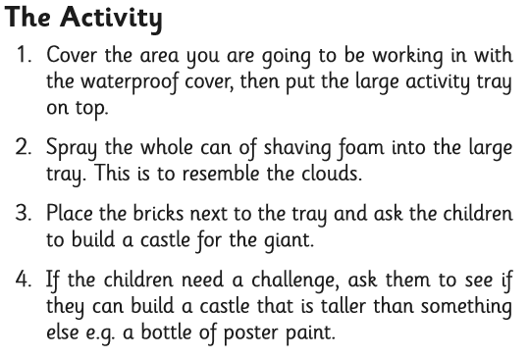  Building Rainbow Bricks  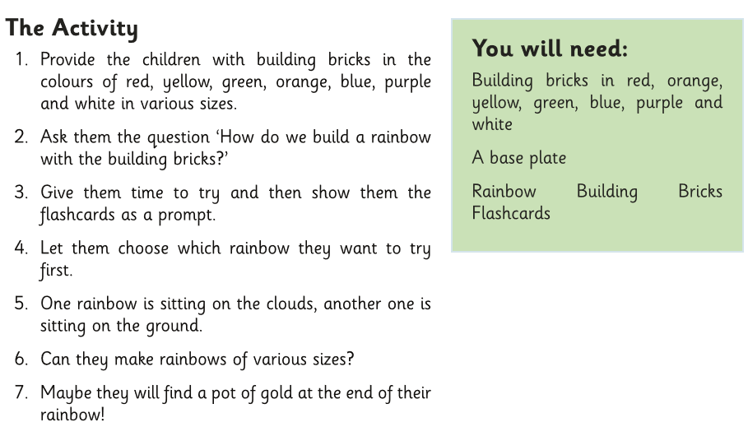  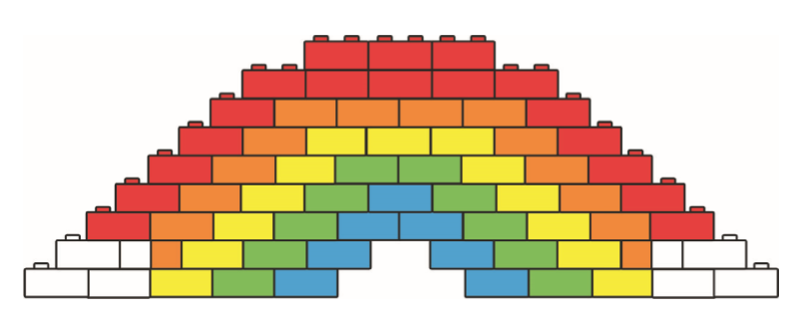  Floating Dinosaur Rescue  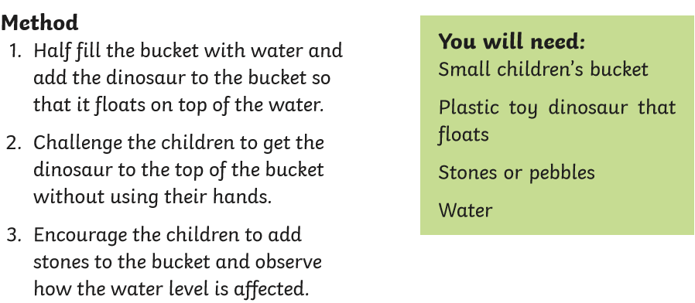  The Gingerbread Man Boat Rescue  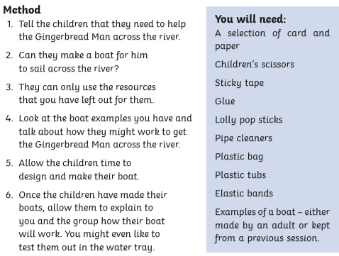  Bicarb and vinegar experiment.  Witches potion  Skittles and Water  Connections Activities:  Animal Footprints  String Telephones  We are all different | Skill focus:  Experimenting with a range of resources and investigating the results. (science experiments).  Charanga- Term 4 – music lesson 4
WK-5  WB 18.04.2024 | Vehicles week | Same as week 1 | I can listen attentively and talk about what I hear, taking turns in conversations with my peers and teacher.  I can talk about my experiences using full sentences and the correct tense (with support).  I can ask questions and make comments from group discussions. | I can recognise and talk about different feelings.  I can talk about how I might feel in different situations. | I can use the principles of pinchy parrot fingers for correctly holding different tools.  I can use the PE equipment safely with good control with awareness of the people around me.  I can perform basic balances and stretches in PE with increased control.  I can cut out a variety of shapes on different textures confidently.  I consider the shape, size and details in my drawings, I can make them smaller/larger where appropriate. | I can apply the Level 1+ and Level 2 graphemes to my reading and writing mostly consistently.  I can blend sounds to read words and sight read some familiar words, particularly VC words.  I can sometimes use a capital letter, finger space and full stop in my sentence writing, but I am not yet consistent with this.  I can talk about the text I read in both fiction and non-fiction texts and make links to my own thoughts, opinions and experiences. | I can talk about the different Number bonds of 5.  I can use the Part Part Whole Model and Ten Frame to demonstrate the number bonds of 10.  I can order a familiar routine or event. | I can talk about the lives of people around me and their roles in society.  I can talk about similarities and differences between things in the past and now. | I show a good understanding of how to use more complex tools and the safety precautions needed to use them e.g. how to use a saw, a vice and a hammer for D and T projects.  I can apply my previous learning to new learning and utilise a mixture of familiar resources, tools and skills when creating new pieces.  I can participate in dancing, singing and performing and can make a brief description of what music I have listened to e.g. to say if it is a fast song, slow song, happy beat or sad. | D & T – vice, saw, safety  Vehicles  Familiar routines
 |  |  | Listening carefully - Play audio sounds of different transport and encourage children to match the sound to the picture.  Listen to the sounds we hear outside and try to identify – aeroplanes, cars, emergency vehicles.  Listen to stories and non-fiction books about different types of transport and ask and answer questions.  Look at pictures of transport and describe using a wide range of vocabulary.  Encourage careful listening by describing a vehicle for children to identify eg size, colour, number of wheels.  Role play a ‘magic carpet’. Sit on a rug together and encourage children to talk about where they might go and what they might see. | Talking about and recognising different feelings.  Relating feelings to different situations and talking about what it feels like.  Recognising ways that can help when we feel a certain way – happy, sad, etc.  Sharing stories about feelings. | Introduce and practice use of saw and vice (D&T resources)  Vehicle design using grid paper – consider size, shape of car and wheels etc.  PE – Twinkl plan 5 – Jumping and Rolling  Handwriting in books – graphemes from phonics this week. | Recap using ‘because’ to extend writing further e.g. I would have a red car because…  Floppys phonics Level 2 - /CKS/ /TCH/ | Practising numberbonds of 5 – songs and rhymes.  Practising number bonds of 10 – Part Part Whole Model/Ten Frame – Maths Dollop, counting collections.  Talking about routines and ordering a familiar routine, eg getting up, making a sandwich, etc. | Think about their environment – what vehicles do they see? What sort of people have to use those vehicles? Why? (airport/emergency services/trains) Would you catch a train to Tesco?  Identifying vehicles from the past and now. Can you spot some similarities and differences? (Transport in the past and present photo cards) | Skill focus:  D and T trolley – sawing wood.  Understand how to secure wood in a vice.  Learn the safety rules when using tools.  Sawing a piece of wood as practice.  Sawing dowelling for the purpose of making a moving vehicle (Box modelling).  Charanga- Term 4 – music lesson 5
WK-6  WB 25.04.2024 | Easter week | Same as week 1 | I can express my ideas and feelings about my experiences using full sentences.  I can listen carefully and join in with songs and actions.  I can take turns in conversations with my peers and teachers. | I can show independence in the classroom and am able to organise myself and look after my belongings.  I can talk about the BRILLIANT Expectations and can recognise what is right and wrong and why.  I can talk about Easter and the ways that it is celebrated. | I can perform basic balances and stretches in PE with increased control.  I can use the PE equipment safely with good control with awareness of the people around me.  I can use the principles of pinchy parrot fingers for correctly holding different tools. | I can recognise the Level 1+ and Level 2 graphemes can say their corresponding phonemes.  I know the Level 1+ and Level 2 helpful words by sight.  I can write the Level 1+ helpful confidently and make good attempts at writing the Level 2 helpful words.  I can apply the Level 1+ and Level 2 graphemes to my reading and writing mostly consistently. | I can recognise the coins 1p, 2p, 5p, 10p, 20p, 50p, £1 and £2 and talk about their properties.  I can add coins together to make an amount that is needed.  I can find different ways to make the same amount, eg, 4x1p and 2x2p = 4pence. | I can talk about my experience of Easter and what others in my class do to celebrate.  I can talk about some religious events (Easter) in this country.  I can see and talk about some important processes and changes in spring time in the natural world.  I can name seasons. | I can use a wide variety of art tools with good control and understanding of their purpose.  I show a good understanding of how to use more complex tools and the safety precautions needed to use them e.g. how to use a saw, a vice and a hammer for D and T projects.  I can apply my previous learning to new learning and utilise a mixture of familiar resources, tools and skills when creating new pieces.  I can participate in dancing, singing and performing and can make a brief description of what music I have listened to e.g. to say if it is a fast song, slow song, happy beat or sad. | Independence  Responsibility  Easter – new life, Christian, festival, cross, eggs, spring, bonnets.  Concertina
 |  |  | Learn new songs and develop the confidence to perform in front of others.  Discuss their experience and feelings in full sentences– what did you enjoy? | Understanding the word independence – how can we be more independent?.  Thinking about things we can practice to do to be more independent and responsible, eg make sure our school bag and water bottle is ready, etc.  Revisiting the BRILLIANT Expectations. Talking about particular situations and recognising what is right and wrong and why. | Assessment of gross motor skills – balance, coordination, spatial awareness, confidence climbing up and down, jumping with 2 feet, catching a ball 2 handed.  Mixing – chocolate easter nests.  Name writing assessment – check letter formation (selected children).  PE – Twinkl plan 6 – Jumping and Rolling  Handwriting in books – graphemes from phonics this week. | Phonics assessments – graphemes and helpful words.  Children to ALL be on Red level by this point.  Writing Easter cards – using knowledge of Christmas cards for format and understanding of Capital letters, finger spaces and use of phonics in writing.  Floppys phonics Level 2 - /NK/ | Money – Reinforcing coins.  Adding coins together to make an amount, finding different ways to use coins to make the same amount, playing shops, cafes, etc. | Think about how and why Christians celebrate Easter. How do you celebrate it in your house?  Forest School – Identify the signs of spring.  Show understanding of what is happening in the natural world, link to animals begin born. Plants beginning to shoot. | Skill focus:  Mixing to make Easter cakes/nests – combing textures.  Concertina folding to make legs for a spring chicken – practice one day on paper and then the next day for the purpose of Easter craft.  Charanga- Term 4 – music lesson 6
End of Spring 2 | Bench markers- | I can plan a game or activity and consider what I want to achieve during and after completion.  I can show perseverance with my work.  I can seek help from friends or teachers.  I know the daily routines and can prepare myself for them.  I can make links between my own interests and my learning. | I can hold conversations and talk in a small group.  I can use new vocabulary that I have learned.  I can listen carefully and respond with comments and questions.  I can use new vocabulary in my talk with my friends and peers.  I can offer explanations for why things might happen in stories.  I can use full sentences to describe settings using the correct tense (with teacher support).  I can begin to use conjunctions when I talk and express my ideas and feelings.  I can listen and show understanding of what I have heard through comments and questions.  I can listen carefully to stories, songs and rhymes.  I can take part in listening games.  I can say my ideas to others.  I can listen attentively and talk about what I hear, taking turns in conversations with my peers and teacher.  I can talk about my experiences using full sentences and the correct tense (with support).  I can ask questions and make comments from group discussions. | I show an understanding of my own feelings and those of others.  I am able to work towards simple goals, demonstrating increasing patience and perseverance to complete challenges.  I show focussed attention when an adult is talking and am not distracted.  I form positive relationships with others.  I am able to follow an instruction involving several ideas.  I show increasing independence, resilience and confidence when approaching challenges.  I show an understanding of the Brilliant Expectations and what is right and wrong and why.  I play interactively and co-operatively with others, displaying the ability to share.  I can manage my own basic hygiene and personal needs and show an understanding of what is healthy, eg foods.  I show an awareness of the needs of others and show sensitivity towards these. | I can attempt to turn my socks/tights/clothes the right way round ready for me to wear again.  I can cut out a variety of shapes on different textures confidently.  I consider the shape, size and details in my drawings, I can make them smaller/larger where appropriate.  I can use a variety of pens, pencils, crayons, wax crayons and apply the correct pressure based on which tool I am using at the time.  I am more confident now when using a knife to cut up my own food.  I can perform basic balances and stretches in PE with increased control.  I can use the PE equipment safely with good control with awareness of the people around me.  I can use the principles of pinchy parrot fingers for correctly holding different tools. | I can recognise the Level 1+ and Level 2 graphemes can say their corresponding phonemes.  I know the Level 1+ and Level 2 helpful words by sight.  I can write the Level 1+ helpful confidently and make good attempts at writing the Level 2 helpful words.  I can apply the Level 1+ and Level 2 graphemes to my reading and writing mostly consistently.  I can blend sounds to read words and sight read some familiar words, particularly VC words.  I can sometimes use a capital letter, finger space and full stop in my sentence writing, but I am not yet consistent with this.  I can talk about the text I read in both fiction and non-fiction texts and make links to my own thoughts, opinions and experiences. | I can talk about features and routes on a map.  I can draw a map showing features in the correct position and proximity to each other.  I show an understanding of positional language.  I can describe where something is using positional language.  I show an awareness of number bonds to 5.  I show an awareness of number bonds to 10.  I can recognise and talk about some familiar coins.  I can add coins together to make a given amount.  I am able to add and subtract an amount using a numberline or ten frame.  I can order a familiar routine. | I can explore the natural world around me and make observations.  I can identify animals, make observations and draw them.  I can say how some animals are similar and different.  I can understand settings in the past through books and storytelling.  I can understand important processes in the changing state of matter.  I can talk about some similarities and differences between the past and now.  I can talk about the lives of people around me and their roles in society.  I can talk about my experience of Easter and what others in my class do to celebrate.  I can talk about some religious events (Easter) in this country.  I can see and talk about some important processes and changes in spring time in the natural world.  I can name seasons.  Science Week  I can have my own ideas about what happened and why.  I can use equipment and tools safely.  I can explore the world around me and make observations.  I can show understanding of important processes and changes. | I have a good understanding of colour mixing and can carefully select colours for specific purposes.  I can use tessellation confidently for collaging.  I can use a wide variety of art tools with good control and understanding of their purpose.  I show a good understanding of how to use more complex tools and the safety precautions needed to use them e.g. how to use a saw, a vice and a hammer for D and T projects.  I can apply my previous learning to new learning and utilise a mixture of familiar resources, tools and skills when creating new pieces.  I can participate in dancing, singing and performing and can make a brief description of what music I have listened to e.g. to say if it is a fast song, slow song, happy beat or sad. | Tier 2:  Positional language – directions  Silhouette  Concertina  Healthy, unhealthy  Tier 3:  Easter  Science week, experiments

