Welcome to Banks Road Infants School
with Cheeky monkey.
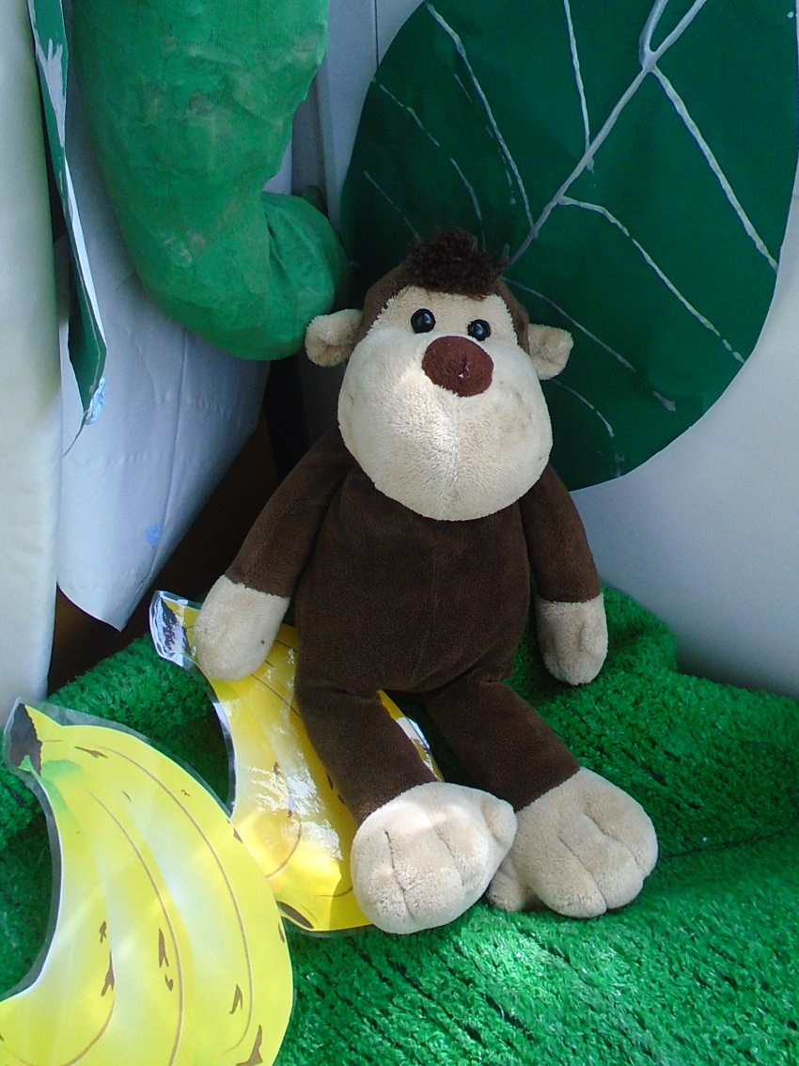

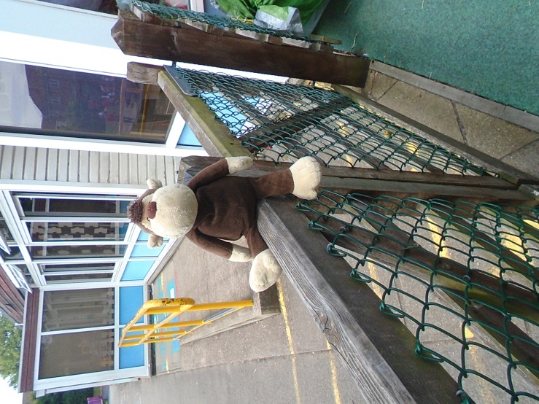
Cheeky monkey can’t wait to start nursery. He waits at the gate as he knows he’s not allowed through it without a grown up!

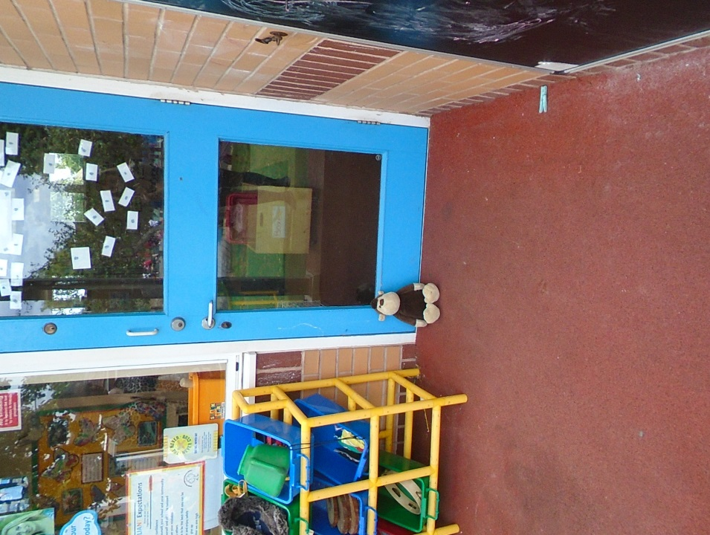

And then he waits outside the nursery for his teachers to open up.

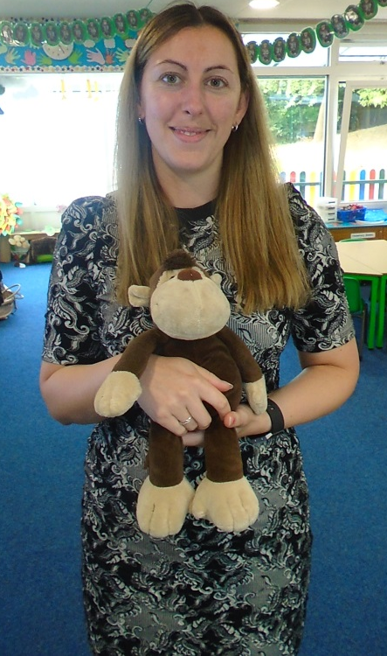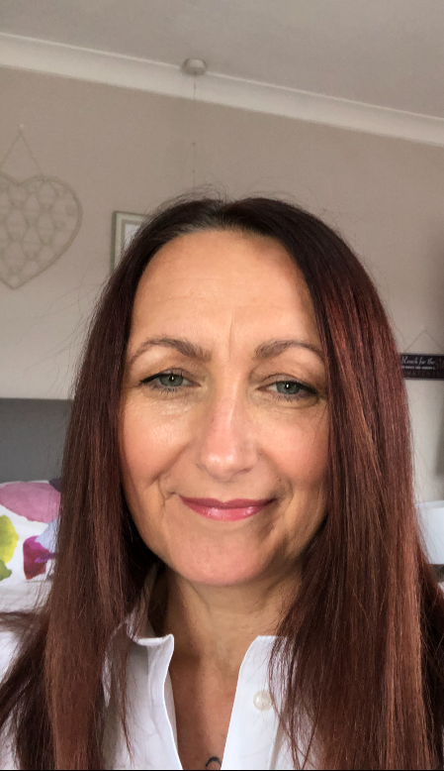

Cheeky monkey says a big hello to
Miss James and Miss Fraser who look after him.

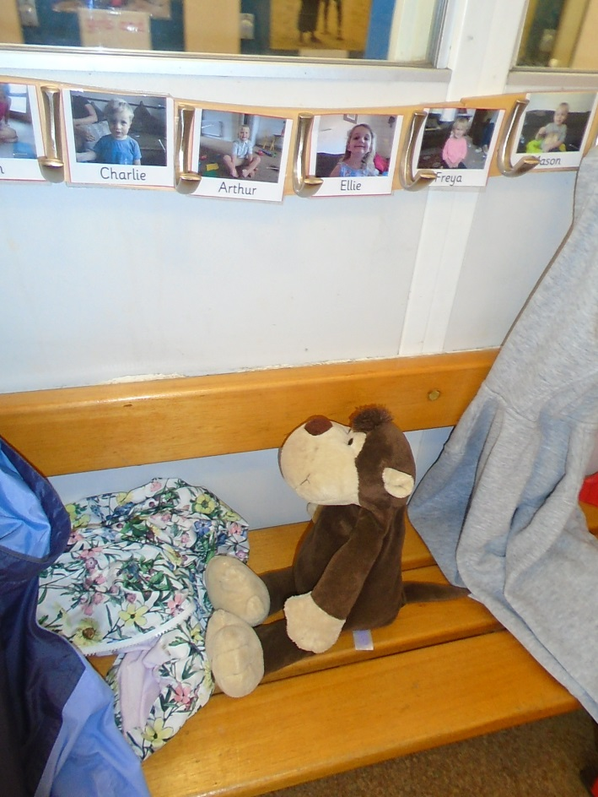
Cheeky monkey hangs up his bag
and coat.

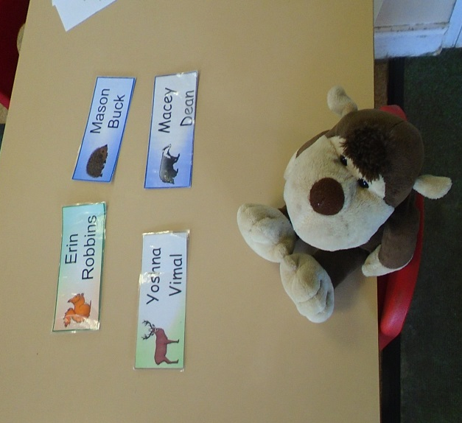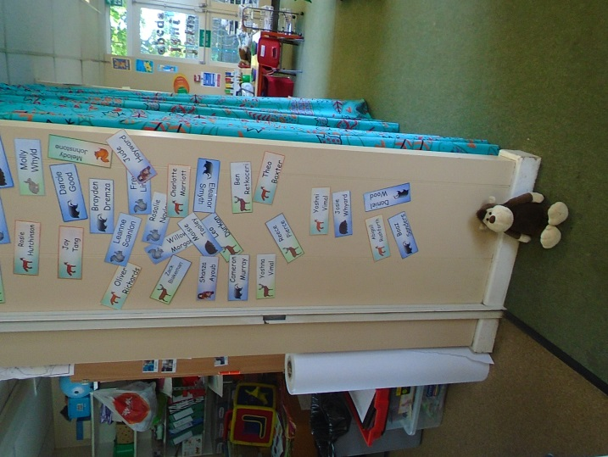

Cheeky monkey looks for his name and then puts it on the wall.

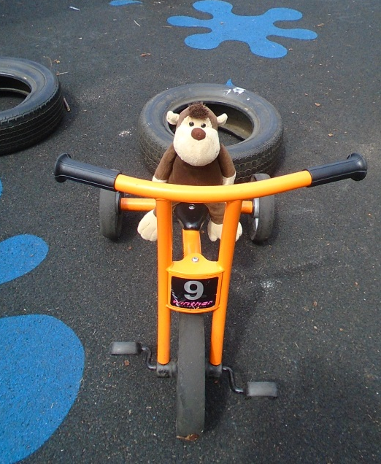
Cheeky monkey likes to play on the bikes although he is still learning how to share with all his new friends; do you think you could show him?

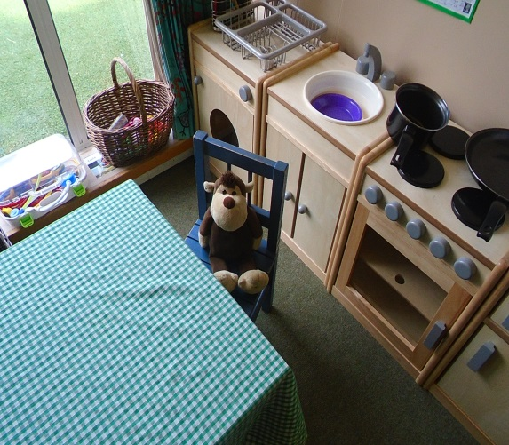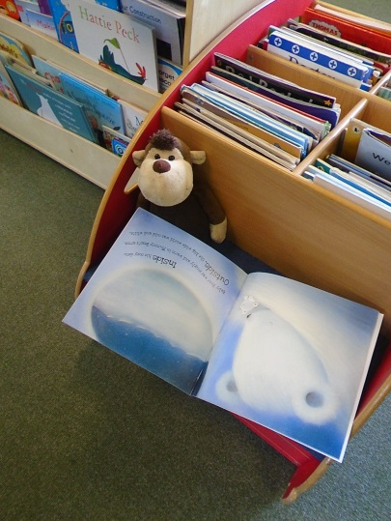

Cheeky monkey loves playing in our home corner and reading.
You can tell him all about your favourite stories.

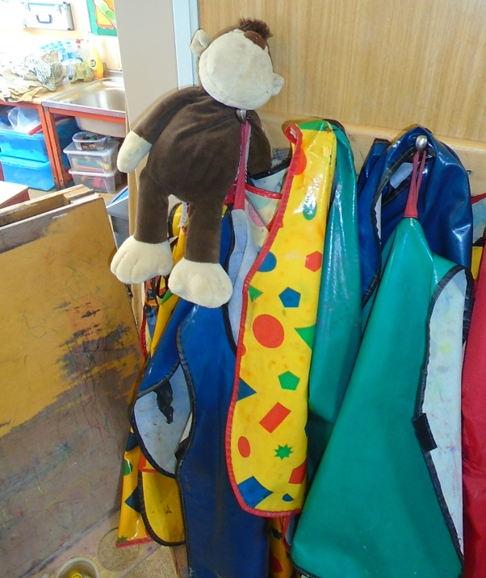

Cheeky monkey enjoys playing in the water, don’t forget your apron!

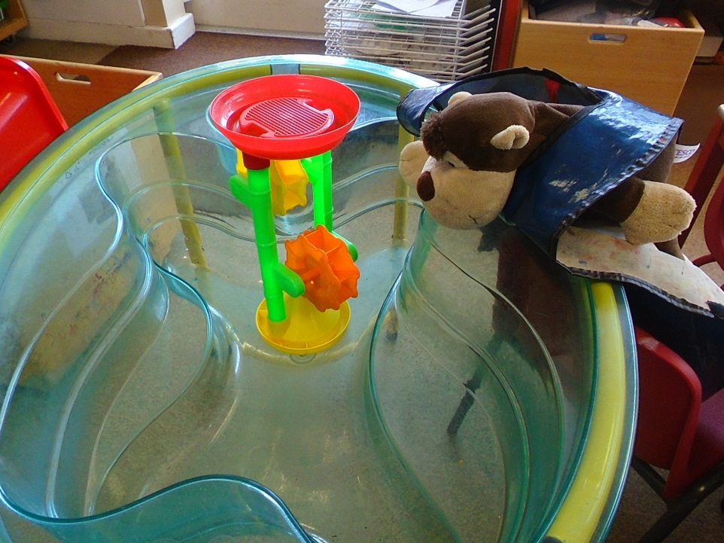

Make sure you keep the water
inside the tray cheeky monkey!

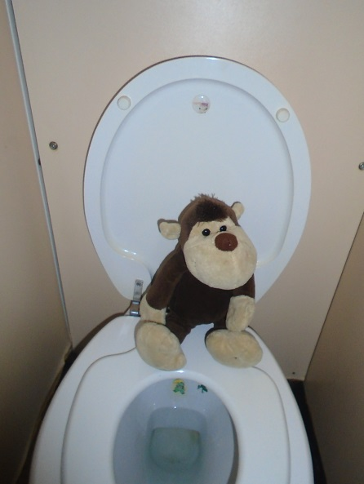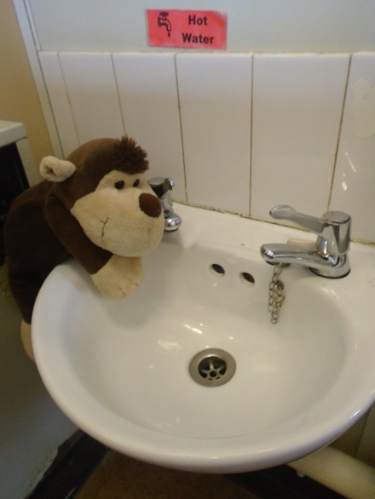
Oh no all that water play has made cheeky monkey need the toilet. He knows that Miss James and Miss Fraser will help him with his buttons if he needs it.
Don’t forget to wash your hands cheeky monkey!

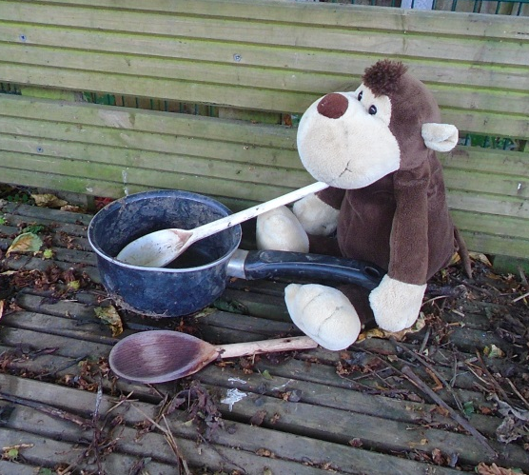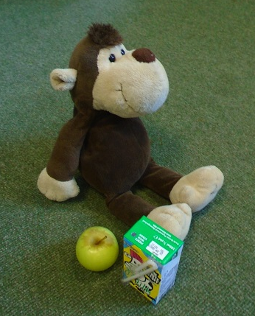

Some days Cheeky monkey gets to go into the forest school and make mud pies. All this cooking has made cheeky monkey hungry, time to go inside and wash our hands for snack time.

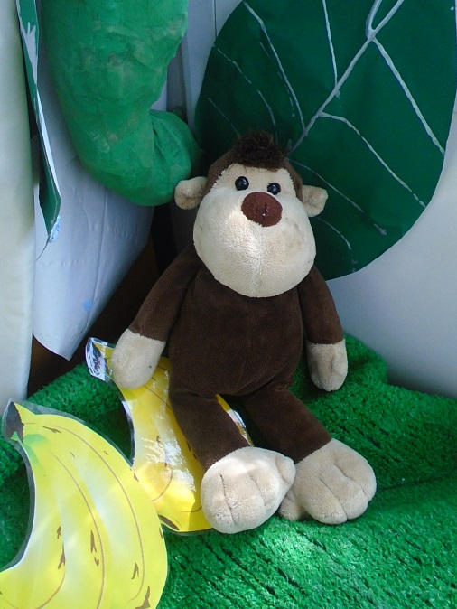
Cheeky monkey is really excited for nursery, are you?

